January 23, 2007

Jeff Miner
Radon At Tahoe
PO Box 2576
South Lake Tahoe, CA 96158

Subject: Newborn Radon Program Grant application

Grant Administrator,

Radon at Tahoe is seeking a $450 grant to publish and distribute radon information, with a request for a free radon test kit, to all parents of newborn babies born in local hospitals. The program is called the Lake Tahoe Newborn Radon Program and is modeled after the successful Newborn Radon Program in Pennsylvania and now in at least three other states.

The Surgeon General has determined that radon is the second leading cause of lung cancer after smoking. Over 20,000 people die each year from radon induced lung cancer. He has issued a radon cancer warning similar to the one we are all familiar with on cigarette packages.

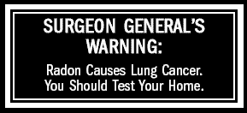

Radon is a naturally occurring radioactive gas that is found in most soils, but is especially prevalent in the granitic soils of the Sierra Nevada. Studies have shown that the Sierra Nevada region around Lake Tahoe has high levels of radon.

- A 1991 California Department of Health Services (DHS) study identified the Sierra Nevada region of California as the highest radon region in the state with “11 – 45% of the homes over the EPA Acton Level of 4 pCi/L (picoCuries per liter).”
- A 1989 Nevada study listed Zephyr Cove as having the highest percentage of homes over the EPA Action Level of any city or town in the entire state of Nevada – 69%! Nevada averages 10% of homes over 4 pCi/L.

- The California DHS Radon Program has begun a detailed geological radon mapping of the Lake Tahoe area.. This past December 7,700 residents in El Dorado, Placer and Nevada Counties were asked to participate in that study.

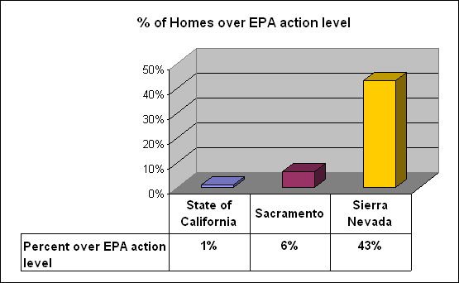

- A recent study of the California Radon Test database showed 25 zip codes in 14 communities near Lake Tahoe as having an average of 43% of homes over the EPA Action Level, compared to 6% for the greater Sacramento region and only 1% for the entire state of California.

Our higher than average radon levels along with the Surgeon General’s cancer warning encourage us to take action to get more people to test their homes. The Lake Tahoe Newborn Radon Program is one way to help families provide a health home for their new baby and for themselves.

The Newborn Radon Program uses an existing radon flyer and simply staples a cover to it with local information about the Newborn Radon Program and how to request a free test kit.

Estimated Costs:

Radon in California information pamphlet: Free from the DHS Radon Program

Printing, folding and stapling the cover:
Staples pre-tax Bid:

100 $49.95 $.50 each
500 $220.19 $.44 each
1000 $395.29 $.40 each

Barton Memorial Hospital had 552 births in 2006

An initial grant request would be $450 to print 1000 flyers to cover Barton’s 2007 needs. The extras would be used to promote the Lake Tahoe Newborn Radon Program to other local hospitals during 2007.

Jeff Miner
Radon at Tahoe
http://www.radonattahoe.com
jeffminer@etahoe.com
530-577-7293

